Experiment no.: 09
Title: Demonstrate the use of following tools:
- Samspade
- Nslookup
- Whois
- Tracert
Course Outcome: Build systems that are more secure against attacks.
Theory:
- SamSpade: Multi-tool for network diagnostics (legacy; features include DNS queries, WHOIS lookups, traceroute).
- Nslookup: DNS query tool to resolve hostnames to IPs and query DNS records.
- Whois: Retrieves domain registration and ownership information from WHOIS databases.
- Tracert / Traceroute: Shows the route packets take to reach a destination and the round-trip time per hop.
Advantages:
- Quick visibility into DNS, domain ownership, and network path issues.
- Useful during reconnaissance for troubleshooting and incident response (ethical/legal use only).
- Helps verify DNS configurations and identify misconfigurations.
Algorithm/Methodology:
- Nslookup:
  - Run nslookup example.com to get A record; specify record types (nslookup -type=MX example.com) to query MX, TXT, etc.
- Whois:
  - Run whois example.com or use web WHOIS clients to view registrant, registrar, creation/expiry dates.
- Tracert/traceroute:
  - Run tracert example.com (Windows) or traceroute example.com (Linux/Mac) to view intermediate hops and latency.
- SamSpade:
  - Use built-in modules for DNS, WHOIS, traceroute, and other lookup tasks (note: SamSpade is older — many functions are replaced by modern CLI tools).
- Record outputs and interpret results: DNS misconfigurations, stale records, routing bottlenecks, or suspicious registrar info.
SamSpade
SamSpade is a graphical network query tool used to gather information about domains and IP addresses. It provides several utilities such as Whois lookup,
DNS lookup, traceroute, ping, and email header analysis. It is primarily used in network troubleshooting and for investigating spam or cyber incidents. SamSpade allows users to view domain registration details, identify mail servers, trace routes, and analyze the origin of network connections in a simple interface.
Purpose:
- To collect domain information and trace internet connections.
- To perform DNS queries and Whois lookups for identifying domain owners.
- To analyze spam or suspicious email origins.
Steps:
- Open the SamSpade application.
- Enter a domain name (for example, google.com) in the address bar.
- Click on the desired operation such as Whois, Trace, or DNS.
- The results will display information related to the selected operation.

Output:
The tool displays details like domain registrar, registration and expiry dates, DNS servers, and IP tracing information.

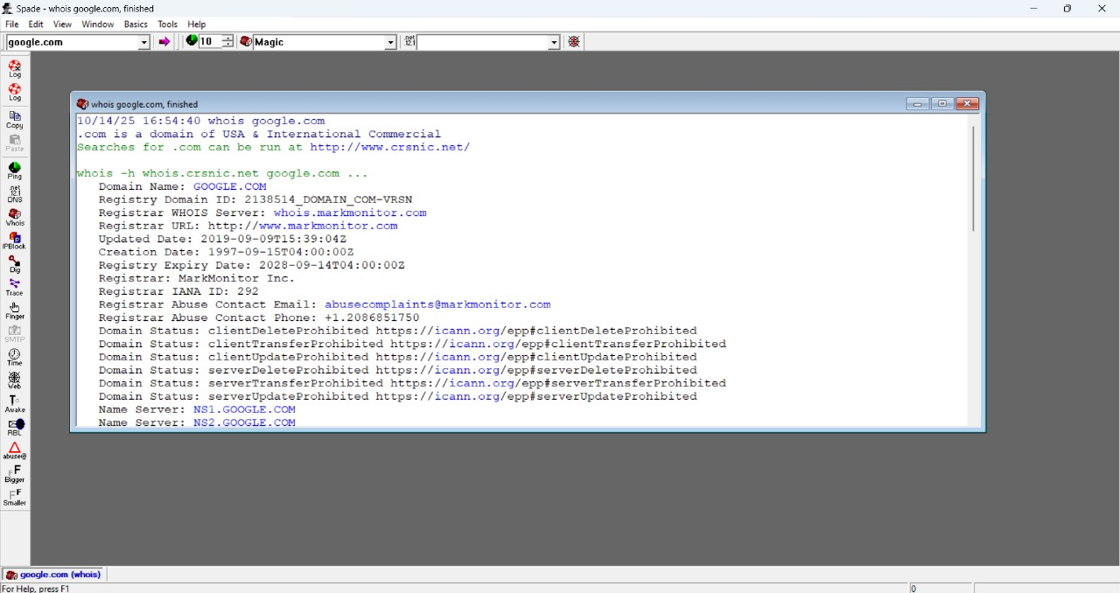
2. Nslookup
Theory:
Nslookup (Name Server Lookup) is a command-line tool used to query Domain Name System (DNS) servers to obtain domain name or IP address mappings. It helps network administrators verify DNS configurations and troubleshoot domain-related problems. The tool can be used in both interactive and non-interactive modes.
Purpose:
- To find the IP address corresponding to a domain name.
- To verify DNS records and detect DNS issues.
Command Syntax:
nslookup [domain name]
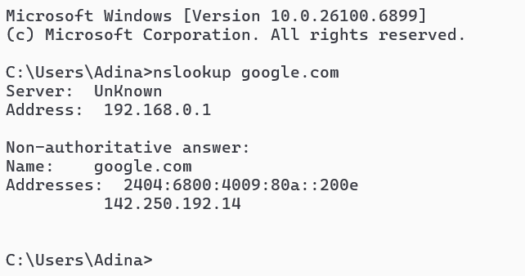
Result:
Displays the IP address and DNS server information of the specified domain.

3. Whois
Theory:
Whois is a network utility that retrieves domain registration details from a global database maintained by domain registrars. It provides information such as the domain owner’s name, organization, contact information, registration date, expiry date, and name servers. This tool is commonly used for domain verification and cyber investigation purposes.
Purpose:
- To identify the registered owner and administrative details of a domain.
- To verify domain authenticity and detect potential fraudulent sites.
Command Syntax:
whois [domain name]
Result:
Displays registration details such as registrar, creation and expiry dates, and contact email of the domain owner.
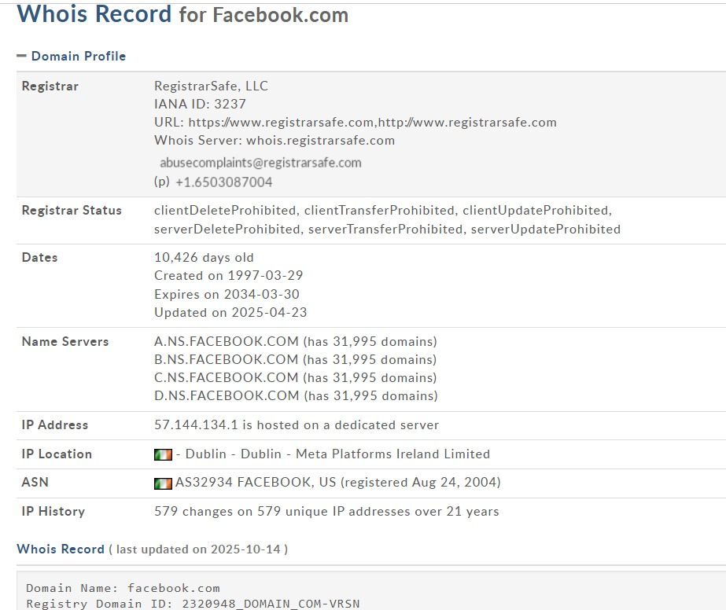
4. Tracert
Theory:
Tracert (Trace Route) is a command-line utility used to track the route that data packets take from the local computer to a destination host. It helps identify each hop (router or gateway) along the path and measures the time it takes to reach each. This tool is useful for diagnosing network connectivity problems and locating where delays or failures occur.
Purpose:
- To trace the path packets take to reach a destination.
- To detect network delays or failures along the route.
Command Syntax:
tracert [domain name or IP address]
Result:
Displays each hop between the local system and the destination server along with the response time for each hop.
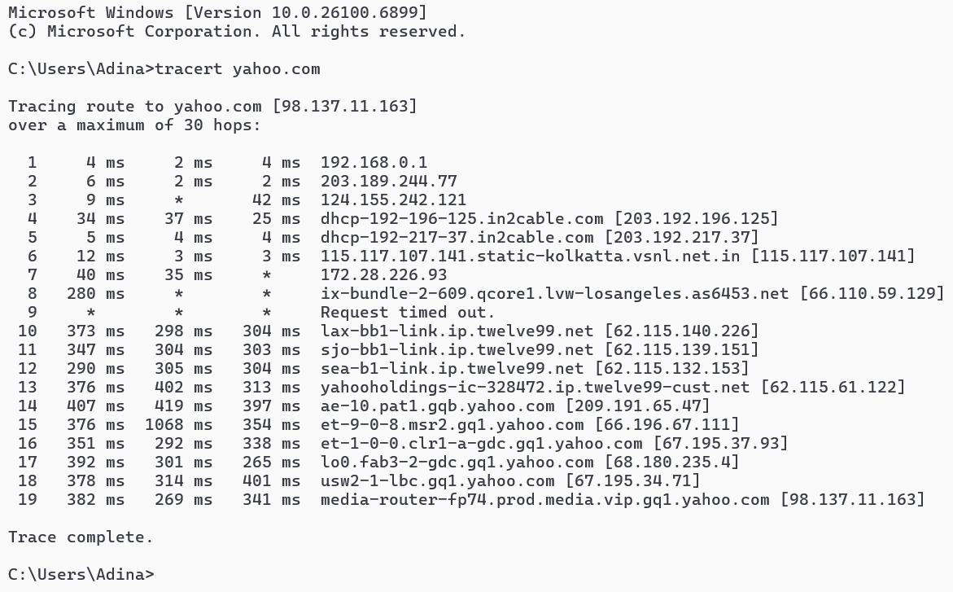

Conclusion:
I have successfully demonstrated the use of SamSpade, Nslookup, Whois, and Tracert tools.

